Detecting SQL Injection (SQLi) Attacks in Security Onion
Continuing my blue team lab journey, I simulated and analyzed SQL Injection (SQLi) attacks against a vulnerable web application (DVWA) to study how Security Onion, Zeek, and Suricata detect and correlate web-based threats.

Scenario 3 — SQL Injection Simulation
Goal: Detect SQLi attempts in network traffic and correlate Suricata alerts with Zeek HTTP logs.

Steps Performed:
Attack Simulation using sqlmap
Targeted a test web app hosted on a monitored VM:
sqlmap -u "http://10.0.2.15/dvwa/vulnerable.php?id=1" --batch --risk=3 --level=5
sqlmap automatically sent crafted SQL payloads such as:
OR 1=1--
UNION SELECT NULL,NULL--
' OR 'x'='x
The traffic was captured by Security Onion sensors.
Investigation in Security Onion:
Opened Kibana → Suricata Alerts Dashboard to check triggered rules.
Found alerts such as:
ET WEB_ATTACK SQL Injection Attempt
ET POLICY Suspicious SQL Syntax in URL
Checked Zeek http.log for evidence of injected payloads:
Parameters containing ' or 1=1--, union select, and abnormal URL encodings.
Pivoted from Suricata alert → Zeek connection → HTTP request to confirm malicious activity.
Findings:
Multiple SQLi signatures were triggered by Suricata.
Zeek logs showed repeated HTTP GET requests with suspicious query strings.
The attacker IP was identified as the source of the automated enumeration by sqlmap.
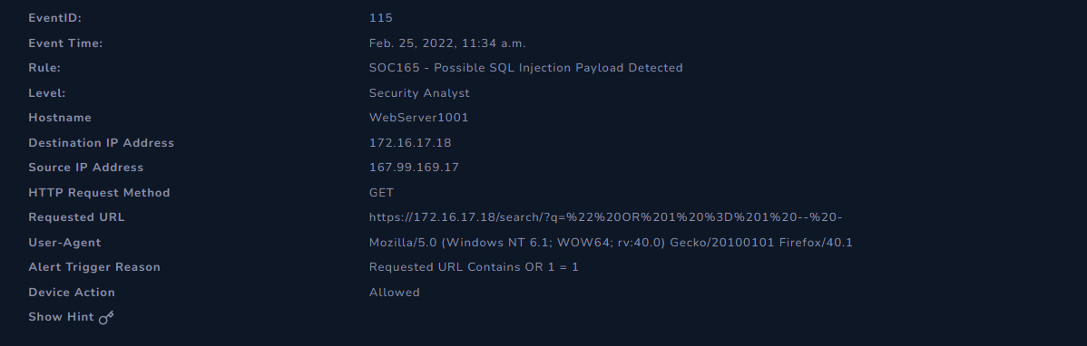

Analysis:
The IDS detected multiple SQL Injection attempts based on payload patterns in HTTP traffic.
Zeek logs validated the findings by revealing malicious query parameters sent to the target web app.

Defensive Measures:
Implemented parameterized queries and input sanitization in the web application.
Monitored HTTP logs for repeated SQL keywords such as UNION, SELECT, and OR 1=1.
Tuned Suricata signatures to reduce false positives and enhance rule precision.

Key Takeaways
SQL Injection remains a critical OWASP vulnerability often detected through network-based IDS rules.
Correlating Suricata alerts with Zeek HTTP logs provides powerful insight into both detection and attack behavior.
Tools like Security Onion enable defenders to visualize, correlate, and respond effectively to real-world web-based threats.
Tools Used:
sqlmap, DVWA, Zeek, Suricata, Security Onion, Kibana
Tags:
#CyberSecurity #ThreatDetection #SQLInjection #WebSecurity #SecurityOnion #Zeek #Suricata #DVWA #BlueTeam #CyberDefense

